# SWINGS:

Swings are introduced from j2sdk1.2 version onwards. Swings provides different window components like awt provides. Swings provides fimilar components like button, textfield, checkbox etc. In addition to these components it also provides exiciting components like TabbedPane, OptionPane, Table etc. Swings provides different features for components that are not available in awt components. For example we can use both icons & Strings as captions for Buttons and Labels.

Swing components are developed by using platform independent code so that the swing components appearance will not change form operating system to operating system, where as awt components are developed by using plotform dependent code. Hence the appearance of awt components differ from operating system to operating system. Swings are light weight components whereas awt components are heavy weight.

We must import the following packages if we are using swing components in our program. They are:

**javax.swing.*;**

**java.awt.*;**

**java.awt.event.*;(for events only)**

**classes:**

**Japplet:** It is a fundemental class for swings. It is extended from 'Applet' class. we can't add swing components directly to Japplet. In 'init()' of 'JApplet' we have to obtain 'Container' class object. By default Japplet doesn't contain any Layout.

**ImageIcon:** This class is used to hold icons. This class object can be used in JLabel & JButton to set icons as captions.

**Constructors:**

**ImageIcon(String filename);**

**ImageIcon(URL url);**

**Note:** **getContentPane()** returns Container class object.

//program that demonstrates swings components

import javax.swing.*;

import java.awt.*;

public class swinglabel extends JApplet

{

public void init()

{

Container cp=getContentPane();

cp.setLayout(new FlowLayout());

ImageIcon icon=new ImageIcon("HLPGLOBE.GIF");

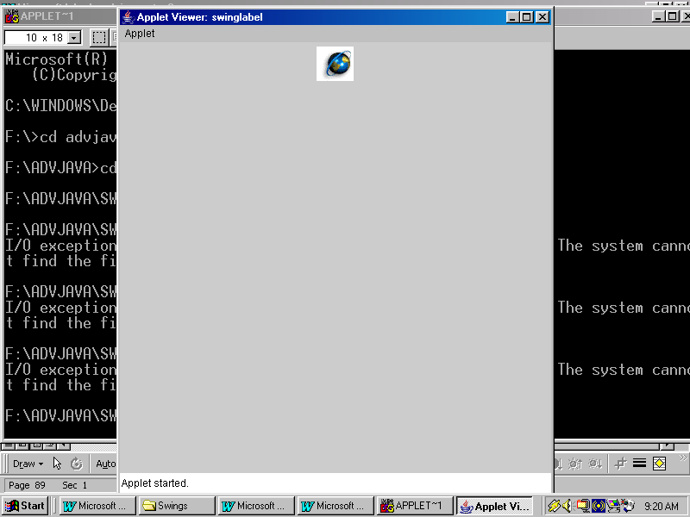JLabel label=new JLabel(“icon,JLabel.CENTER”);

cp.add(label);

}

}

/*<applet code="swinglabel" width="500" height="500">

</applet>*/

**Output:**

//program that that demonstrates JTextField,JButton,JLabel

import javax.swing.*;

import java.awt.*;

import java.awt.event.*;

public class swingclac extends JApplet implements ActionListener

{

JTextField t1,t2,t3;

JButton addr,subt,mult,divd;

public void init()

{

Container cp=getContentPane();

cp.setLayout(new FlowLayout());

t1=new JTextField(20);

t2=new JTextField(20);

t3=new JTextField(20);

addr=new JButton("+");

subt=new JButton("-");

mult=new JButton("*");

divd=new JButton("/");

addr.addActionListener(this);

subt.addActionListener(this);

mult.addActionListener(this);

divd.addActionListener(this);

cp.add(new JLabel("Enter no.1"));

cp.add(t1);

cp.add(new JLabel("Enter no.2"));

cp.add(t2);

cp.add(new JLabel("Result:"));

cp.add(t3);

cp.add(addr);

cp.add(subt);

cp.add(mult);

cp.add(divd);

}

public void actionPerformed(ActionEvent ae)

{

double a,b,c;

a=Double.parseDouble(t1.getText());

b=Double.parseDouble(t2.getText());

if(ae.getSource()==addr)

{

c=a+b;

}

else if(ae.getSource()==subt)

{

c=a-b;

}

else if(ae.getSource()==mult)

{

c=a*b;

}

else

{

c=a/b;

}

t3.setText(Double.toString(c));

}

}

/*<applet code="swingclac" width="500" height="500">

</applet>*/

**Output:**

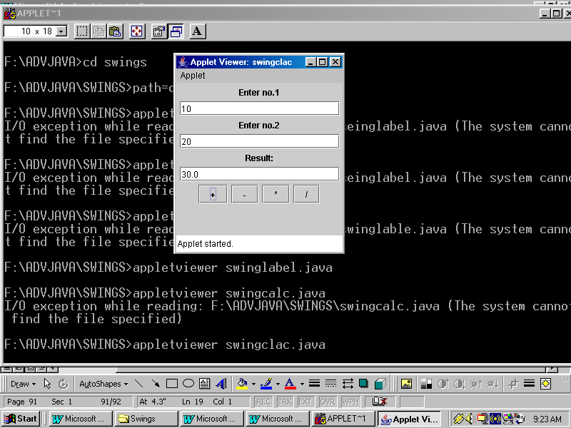

**JoptionPane:** A swing class which is used to display the following dialogboxes.

1.InputDialog

2.MessageDialog

3.ConfirmDialog

It has the following 3 static methods:

1.showInputDialog(String title)

2.showMessageDialog(component parent,String title)

3.showConfirmDialog(component parent,String title)

//program that demonstrates JOptionPane

import javax.swing.*;

import java.awt.*;

public class joptiondemo

{

public static void main(String args[])

{

int eno;

String ename;

double basic,hra,da,pf,net;

String s;

s=JOptionPane.showInputDialog("Enter Employee number");

eno=Integer.parseInt(s);

ename=JOptionPane.showInputDialog("Enter Employee name");

s=JOptionPane.showInputDialog("Enter Basic salary");

basic=Double.parseDouble(s);

hra=basic*20/100;

da=basic*10/100;

pf=basic*8/100;

net=(basic+hra+da)-pf;

JOptionPane.showMessageDialog(null,"Employee Number:"+eno+"\nEmployee Name:"+ename+"\nBasic Salary"+basic+"\nHRA:"+hra+"\nDA:"+da+"\nPF:"+pf+"Net Salary:"+net);

}

}

**Output:**

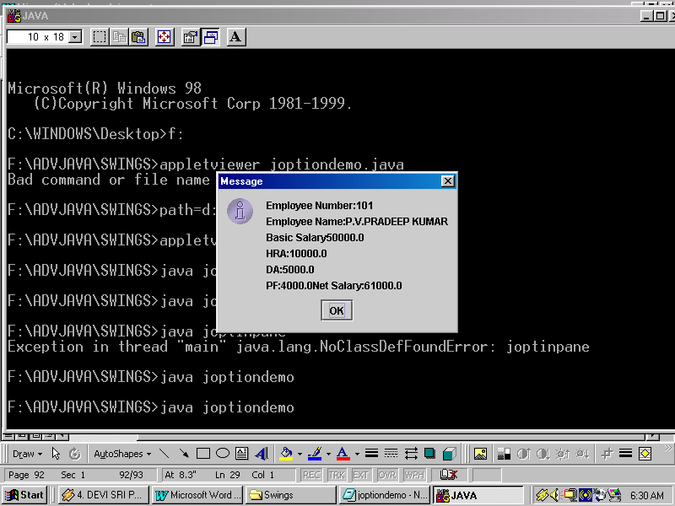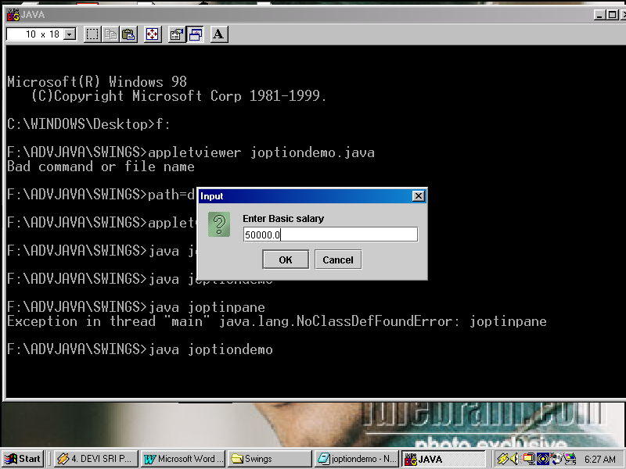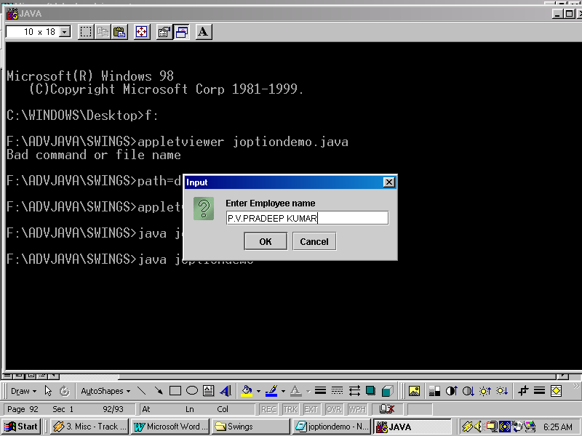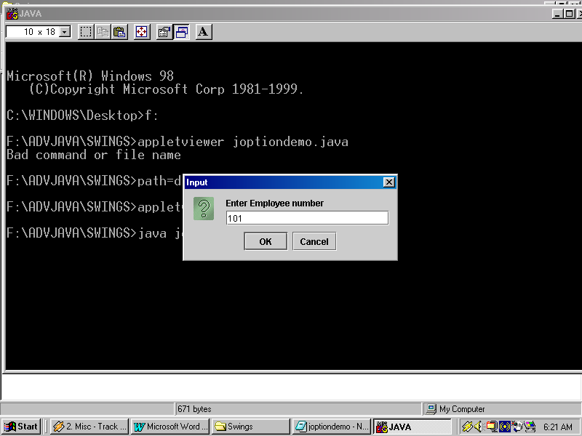

**JcheckBox:** A swing class used to create CheckBox control.

**Constructors:**

**JcheckBox(String caption)**

**JcheckBox(Icon icon)**

**JradioButton:** A swing class which is used to create Radiobuttons.

**Constructors:**

**JradioButton()**

**JRadioButton(Icon icon)**

**JRadioButton(String caption)**

**JradioButton(String caption,boolean state)**

**JcomboBox:** A swing class which is used to create combobox control.

**Constructor:**

**JcomboBox()**

**Jpanel:** A panel is a container which can hold another container or components.

**Constructor:**

**JPanel()**

**JTabbedPane:**

To create JtabbedPane follow the given steps.

1.Create different panels using 'Jpanel' class.

2.Create 'JtabbedPane' object.

3.Attach the panels to JtabbedPane by using the following method.

**addTab(String caption,Jpanel obj)**

4.Add 'JtabbedPane' object to container by using the following method.

**add(JTabbedPane obj)**

//program that demonstrates JTabbedPane

import javax.swing.*;

import java.awt.*;

public class jtabbeddemo extends JApplet

{

public void init()

{

JPanel jp1=new JPanel();

JCheckBox red=new JCheckBox("Red");

red.setBackground(Color.red);

JCheckBox yellow=new JCheckBox("Yellow");

yellow.setBackground(Color.yellow);

JCheckBox blue=new JCheckBox("Blue");

blue.setBackground(Color.blue);

jp1.add(red);

jp1.add(yellow);

jp1.add(blue);

JPanel jp2=new JPanel();

JRadioButton chennai=new JRadioButton("Chennai");

JRadioButton hyd=new JRadioButton("Hyderabad");

JRadioButton banglore=new JRadioButton("Banglore");

jp2.add(chennai);

jp2.add(hyd);

jp2.add(banglore);

JPanel jp3=new JPanel();

JComboBox bikes=new JComboBox();

bikes.addItem("Discover");

bikes.addItem("Pulsar");

bikes.addItem("Boxer");

bikes.addItem("Wind 125");

bikes.addItem("Caliber 115");

bikes.setBackground(Color.pink);

jp3.add(bikes);

JTabbedPane jtp=new JTabbedPane();

jtp.add(jp1,"Colors");

jtp.add(jp2,"Cities");

jtp.add(jp3,"Bikes");

Container cp=getContentPane();

cp.add(jtp);

}

}

/*<applet code="jtabbeddemo" width="500" height="500">

</applet>*/

**Output:**

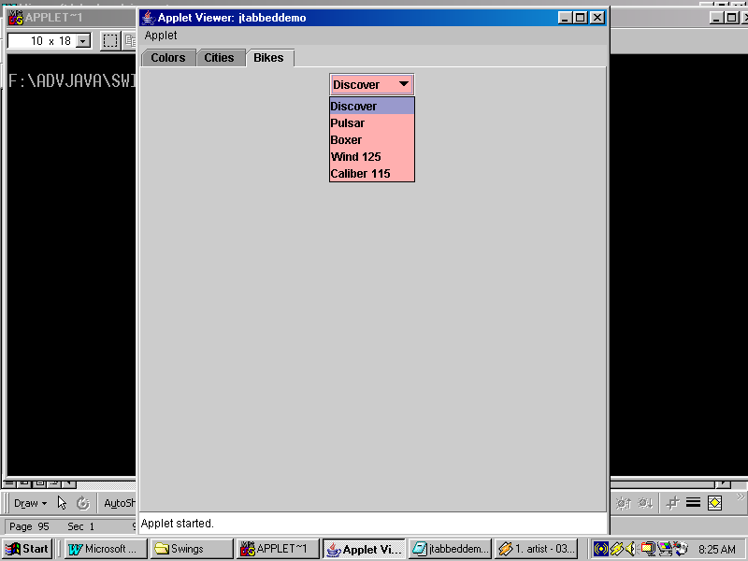

**JScrollPane:** A Swing class which is used as a container that can hold other components.

**Septs to create JscrollPane:**

1.Create the component objects.

2.Create JscrollPane object.

3.Add the component object to JscrollPane by using add().

4.Add JscrollPane to applet.

**Constructors:**

**JscrollPane(component obj)**

**JscrollPane(component obj,vsb,hsb)**

**JscrollPane(vsb,hsb)**

**Scrollbar constants:**

**ScrollPaneConstants.VERTICAL_SCROLLBAR_ALWAYS**

**ScrollPaneConstants.HORIZONTAL_SCROLLBAR_ALWAYS**

**ScrollPaneConstants.VERTICAL_SCROLLBAR_AS_NEEDED**

**ScrollPaneConstants.HORIZONTAL_SCROLLBAR_AS_NEEDED**

**ScrollPaneConstants.VERTICAL_SCROLLBAR_NEVER**

**ScrollPaneConstants.HORIZONTAL_SCROLLBAR_NEVER**

//program that demonstrates JScrollPane

import javax.swing.*;

import java.awt.*;

public class jscrollpanedemo extends JApplet

{

public void init()

{

Container cp=getContentPane();

cp.setLayout(new BorderLayout());

JPanel jp=new JPanel();

jp.setLayout(new GridLayout(30,10));

for(int i=1;i<=300;i++)

jp.add(new Button("Button"+i));

int x=ScrollPaneConstants.VERTICAL_SCROLLBAR_ALWAYS;

int y=ScrollPaneConstants.HORIZONTAL_SCROLLBAR_ALWAYS;

JScrollPane jsp=new JScrollPane(jp,x,y);

cp.add(jsp,"Center");

}

}

/*<applet code="jscrollpanedemo" width="500" height="500">

</applet>*/

**Output:**

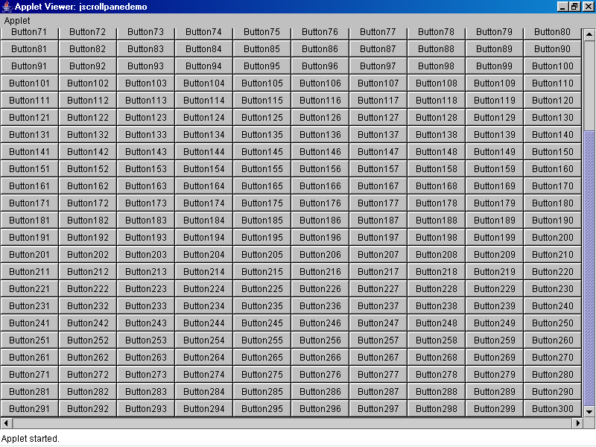

**JTable:** A swing class which is used to display the data values. Its no an independent container. It should be embeded within JscrollPane container.

**Constructor:**

**Jtable(data[],headings[])**

**Steps to create and use the JTable:**

1.Create headings[] and data[] and initialize some values into these arrays.

2.Create JTable object.

3.Create JScrollPane object and add JTable object to JScrollPane using add().

4.Add JScrollPane object to container.

//program that demonstrates JTable

import javax.swing.*;

import java.awt.*;

public class jtabledemo extends JApplet

{

public void init()

{

Container cp=getContentPane();

cp.setLayout(new BorderLayout());

String headings[]={"Employee Number","Employee Name","Salary"};

String data[][]={{"101","Pradeep kumar","50000.0"},{"102","Billgates","45000.0"},{"103","Lakshmi Nivas Mittal","40000.0"},{"104","Ramalinga Raju","35000.0"},{"105","Siva Nadar","30000.0"}};

JTable jt=new JTable(data,headings);

int v=ScrollPaneConstants.VERTICAL_SCROLLBAR_AS_NEEDED;

int h=ScrollPaneConstants.HORIZONTAL_SCROLLBAR_AS_NEEDED;

JScrollPane jsp=new JScrollPane(jt,v,h);

cp.add(jsp,"Center");

}

}

/*<applet code="jtabledemo" width="500" height="500">

</applet>*/

**Output:**

